**Sequence diagrams**

**Use Case 1: View my tickets**

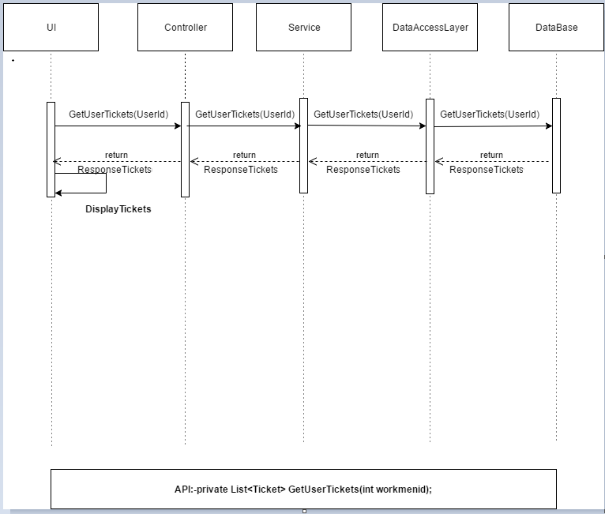

**Use Case 2: View a Ticket Details in HoloLens**

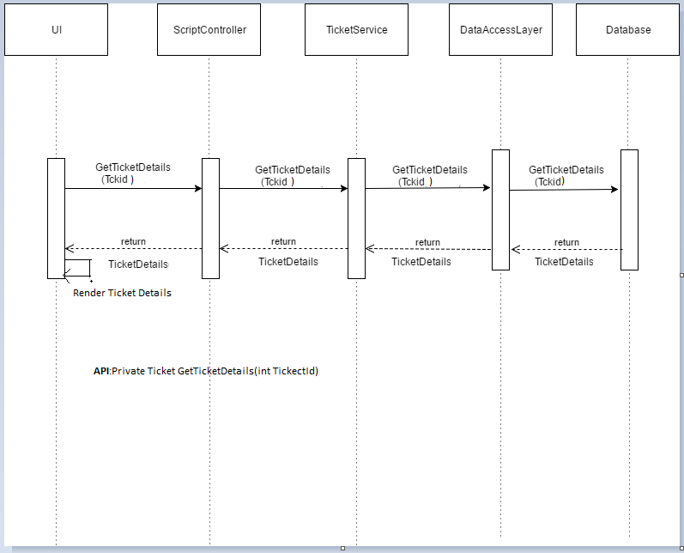

**Use Case 3: Updating the status, comments and observations of Ticket**

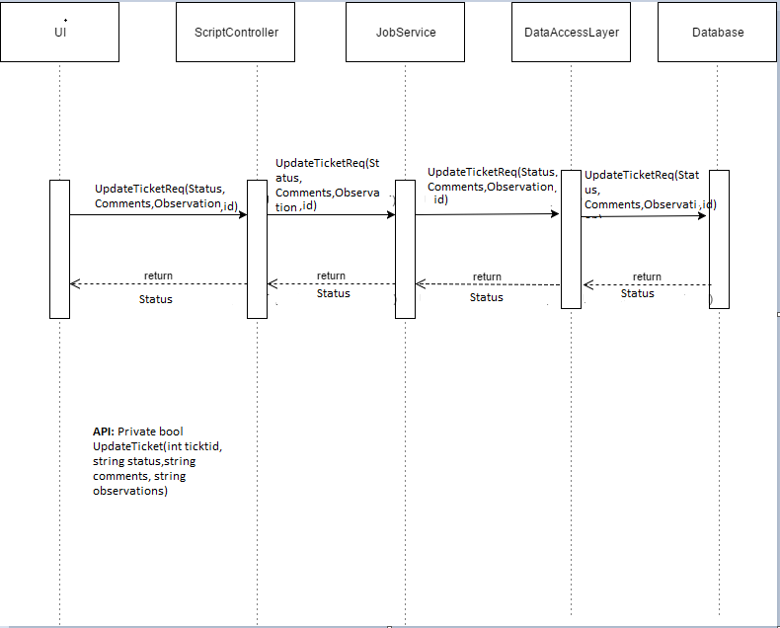

**Use Case 4: View a Video in HoloLens (Video Help)**

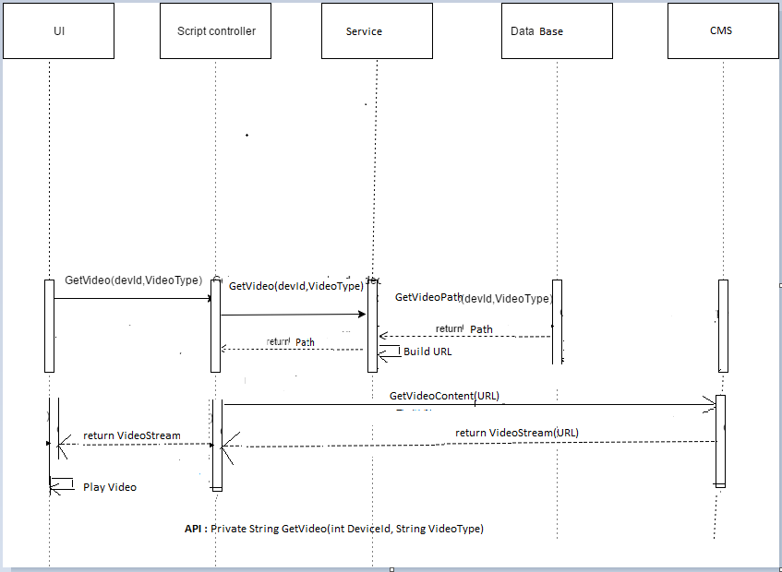

**Use Case 5: Video call to SME**

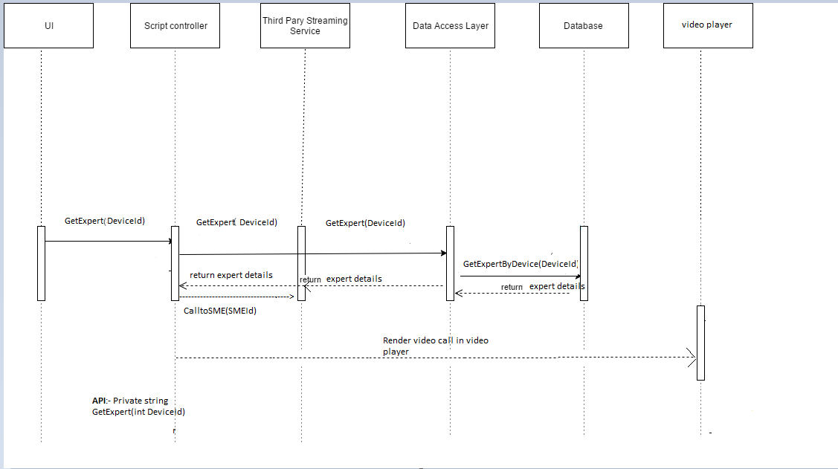

**Class Diagrams**

**Use Case 1: View a Ticket Details in HoloLens**

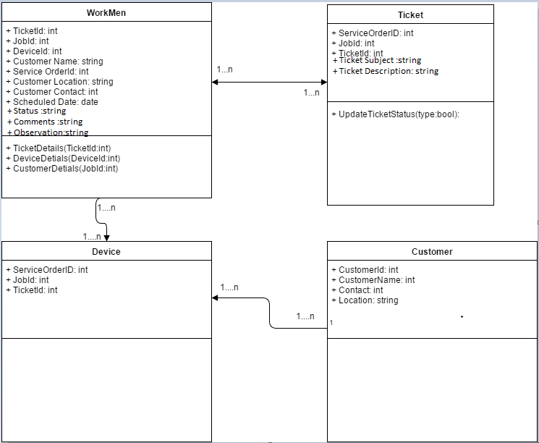

**Use Case 2: Updating the status, comments and observations of Ticket**

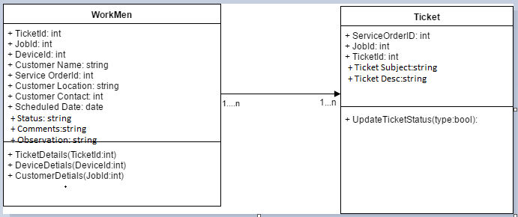

**Use Case 3: View a Video in HoloLens (Video Help)**

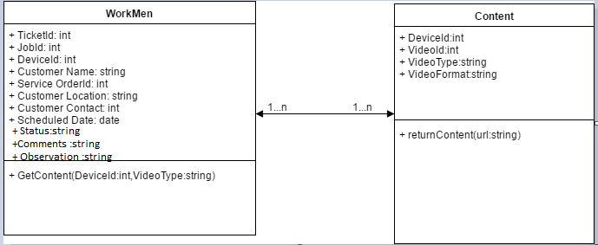

**Use Case 4: Video call to SME**

